**Task 1: Answer the questions in a written form (3 sentences minimum)**

1. Who would you hit up if you needed help finding a job?

Actually, it’s a question of current interest for me. I’m looking for a job right now, and I’m asking my parents to help me. They have a large network of people from companies they had worked with. Also, I’m looking on specific sites like hh.ru.

1. Do you like to mingle with new people at business or social events? Why or why not?

Yes, it’s a great opportunity for me to find some new valuable friends. But, sometimes it’s hard to speak up and reach the new people because of the negative thoughts and anxiety. So I’m trying to think positively and stay in confident mindset.

1. How would you strike up a conversation with a person you'd never met before?

I’d think at first about our potential common interests. So, I’d go to him and just start talking. It’s important to stop being afraid and just be yourself.

1. Who would you like to reach out to and why?

I’d like to reach the professionals of my speciality. It’s a great choice because I’d get new info for me and needed acquaintances. Also, I’d gather new opportunities for my growth as a professional.

1. What are some common icebreakers you can think of?

It can be some informal questions. For example, about hobbies and future. People love to talk about themselves and get positive emotions. So, it could be some funny questions and people would feel comfortable and stay in good mood

1. How important is social capital where you study?

It’s important. Many of your classmates in future possibly could be your coworkers. With appropriate network you can even start to developing a startup.

**Task 2: Listen to the attached audio recording and complete the task**



1. b

2. g

3. a

4. c

5. h

6.d

7.e

8.f

**Listen again and choose True or False**



1.True

2. True

3.False

4.True

5.False

Task 3: Read the text about social networking and complete the definitions with the words in bold

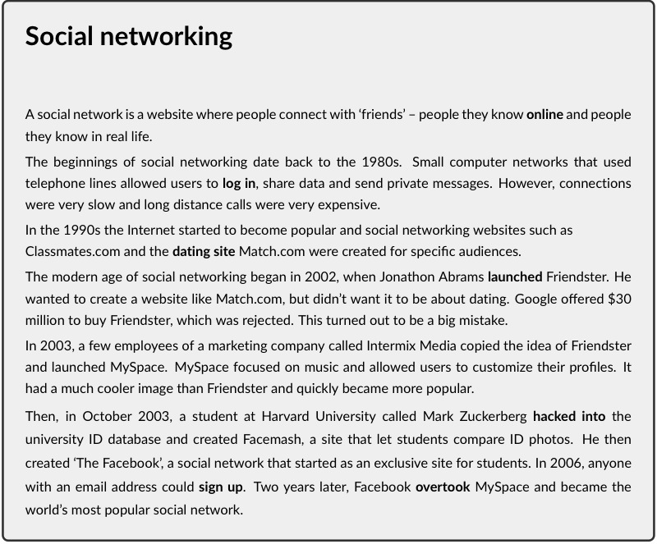

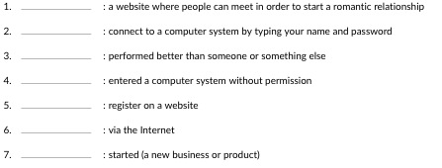

1. dating site

2. log in

3. overtook

4. hacked into

5. sign up

6. online

7. launched

Task 4: Answer the following questions in a written form:

|  |  |
| --- | --- |
| (1) | What is social networking? |
| (2) | What are the pros and cons of social networking? |
| (3) | Are social networking sites dangerous? |
| (4) | Are you good at networking face to face? |
|  |  |

1. It’s some actions on specific sites like linkedin, certain groups for people to discuss their professional interests and get new acquaintances.
2. Pros: New acquaintances, New possibilities for development, developing a social skills, you don’t have to go to specific places to do it, you can stay home.

Cons: Fear and feeling of awkwardness, if you have a lack of experience. You can’t be 100% certain in people who you meet online

1. Not really, if it’s popular sites that many people use. But you should believe everything what Is said there. Think for your own and do your own research.
2. I’m trying to develop this skill. I’m mostly an introvert, so it’s hard to meet a new people. But it’s needed skill for our modern society, because of that, I need to continue doing it.